Topic | Victorian Fur Fashion
Session Aims:
- Develop confidence in reading 19th- and 21st-century non-fiction (articles)
- Explore attitudes and viewpoints in texts
- Analyse language to identify attitudes in texts
Resources
Resource A for Starter and Resource B (‘Fashions’ article from the Graphic, 1891). See pages 3 and 4.

21st-century text: http://www.huffingtonpost.co.uk/entry/faux-fur-bad-for-environment_uk_5811e85be4b04660a4382330

Links with digital revision resource: ‘Murderous Millinery’ slide in Section 3.

Timing | Teacher-led Activity | Learner Tasks  (Linked to Learning Outcome) | Monitoring / Assessment  (of Learner activity and/or learning outcome)
5-10 mins | Introduction: Show images of current fashion models wearing fur (Resource A). Students to write down whether they think the fur is real or fake/faux for each image shown in turn i.e. on PowerPoint slides.  Reveal that all three are examples of faux fur.  Open up discussion about why real fur has been used in fashion and why it has been largely replaced with faux fur now. What do students think about this? | Discussion stimulated by images. | Verbal feedback
20 mins | Reading 21st-century non-fiction:  ‘Why Faux Fur Shouldn't Be Fast Fashion’  http://www.huffingtonpost.co.uk/entry/faux-fur-bad-for-environment_uk_5811e85be4b04660a4382330 | Students to read the article as a class or individually for exam practice.  Students should highlight negative attitudes and reasons not to use faux fur found in the text as they read.  Practice exam question: ‘How does the writer use language to try to convince the reader that faux fur is bad for the environment?’  (12 marks)  Each student picks one word / phrase/ sentence to analyse as a practice exam paragraph. | Peer marking: Students use a basic mark scheme to mark each others’ paragraphs and make suggestions for improvements.
5 mins | Explore this 19th-century fur trade advert:  http://hardyandheritage.exeter.ac.uk/schools-resource/uoedh-the_graphic_1891_vol202329b/
10 mins | Reading 19th-century non-fiction:  Explain how fur fashion became popular in Britain during the Victorian period as a symbol of wealth and luxury related to the success of the British Empire.  Introduce the 1891 text ‘Fashions’ (Resource B). | Students listen to the 1891 text ‘Fashions’ being read by teacher and build a bubble plan* adding each type of fur or animal skin that is mentioned.  (Alternatively, students could be asked to select four facts from the text, as practice for early exam questions.)  *Bubble plan:  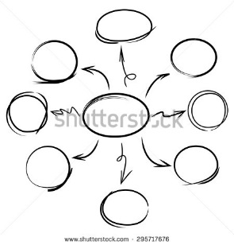 | Answers from text:  - Fox  - Rabbit  - Swansdown  - Persian lambskin / lambskin cloth  - Sealskin  - Seal plush  - Beaver cloth  - Bearskin cloth  Discuss difference between using animals that are farmed anyway and exotic or wild animals.
15 mins | Closer reading of text to identify attitudes.  Facilitate discussion about how the writer shows fur is useful for both practical and aesthetic reasons. | In pairs:  Re-read the text, highlighting 2-4 sentences that show that the writer of this article has a positive attitude to fur being used for fashion.  Students might also want to circle any words or phrases that are difficult to understand while reading. | Pairs feedback.  Suggested sentences:  ‘It is a real pleasure to look at the little mites clothed in white of cream plush … with deep wadded capes, bordered with fox, rabbit, or other skins’  ‘prettiest of all, white Persian lambskin’  ‘Very stylish mantles and paletots are made in sealskin and seal plush’
5 mins | 19th-century language check | Students to add unfamiliar words to the whiteboard  Discuss 19th-century language i.e. damsel, knickerbockers, perambulator | Students could rate how hard this text was to read. (Keep a log as they look through a range of texts in different lessons.)

Homework / Consolidation activity
Section 3 of the digital resource ‘Hardy and his friends’ explores how changing attitudes at the end of the 19th and start of the 20th century meant that more people protested against animals being used in fashion (See ‘Murderous Millinery’).

Resource A

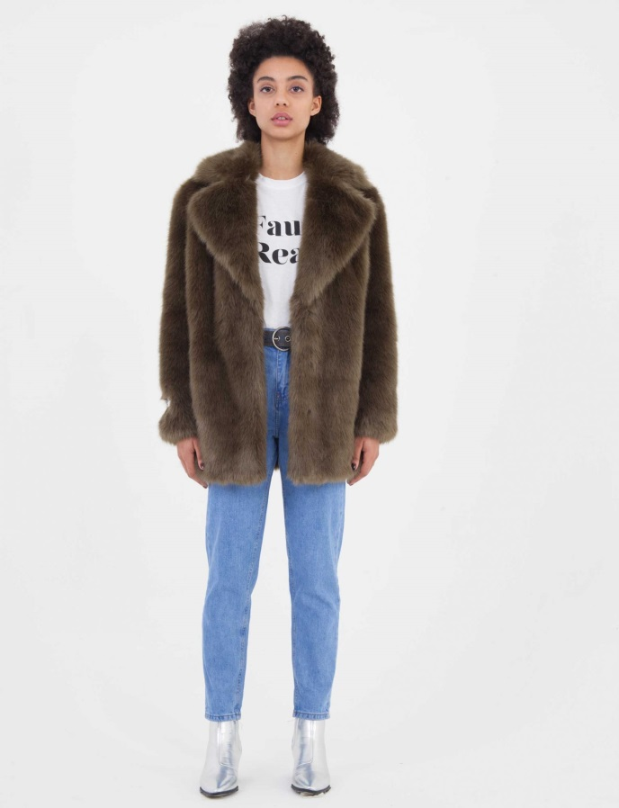
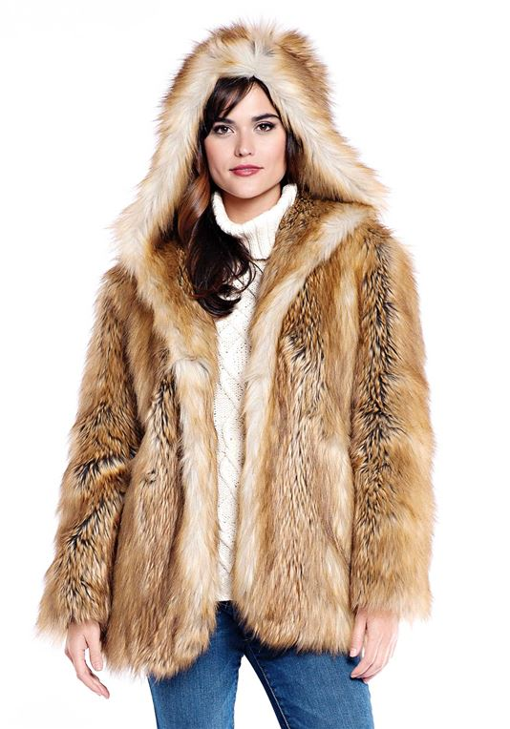

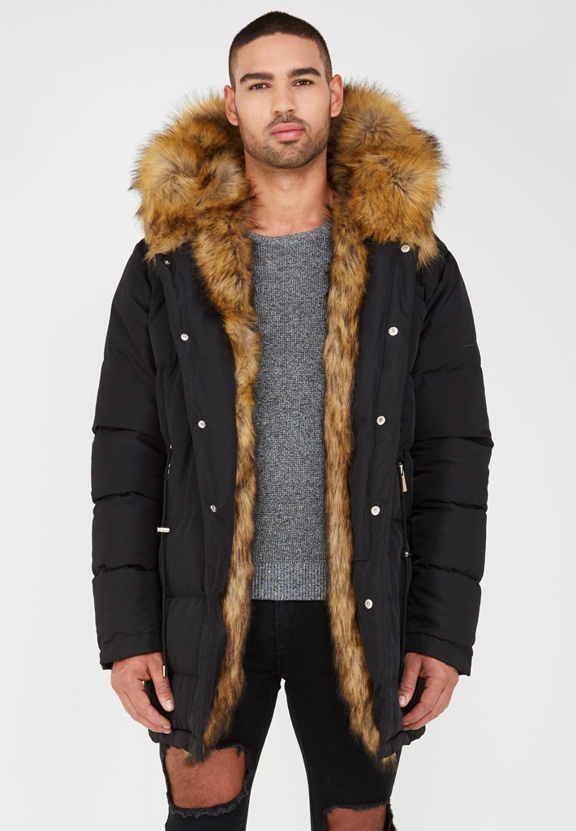
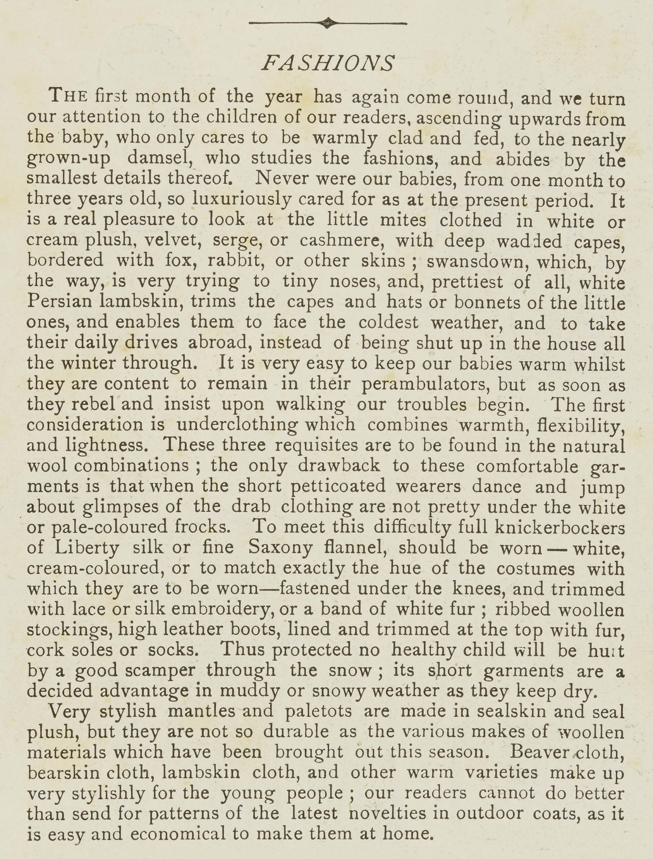
Resource B

Graphic, 1891

