Teaching pack
Subject: 19th- and 20th-century non-fiction texts
Themes: Attitudes to animals; Thomas Hardy and friends
This thematic collection (drawn from special collections at the University of Exeter and the Hardy archives at Dorset County Museum) will allow students to read and understand 19th-century and early 20th-century non-fiction texts, and support them in identifying writers’ attitudes and viewpoints, as well as features of genre, audience and purpose.
Content
- Tale of a Dog (1891)
- Feminine dog-lovers in New York (1891)
- The Graphic front cover (with letter extract) (1891)
- Sunday afternoon at the zoological gardens (1891)
- The naturalist (1891)
- Bird freedom (1891)
- Trained wild beasts at the Crystal Palace (1891)
- Letter to Thomas Hardy about his pet dog, Wessex. (1927)
- Letter from Hardy to his friend Florence Henniker about performing animals (extract) (1913)
- Letter from Florence Henniker to Hardy about the use of feathers in hats (extract) (1914)

High-resolution versions of these texts and illustrations can be saved from the webpage.

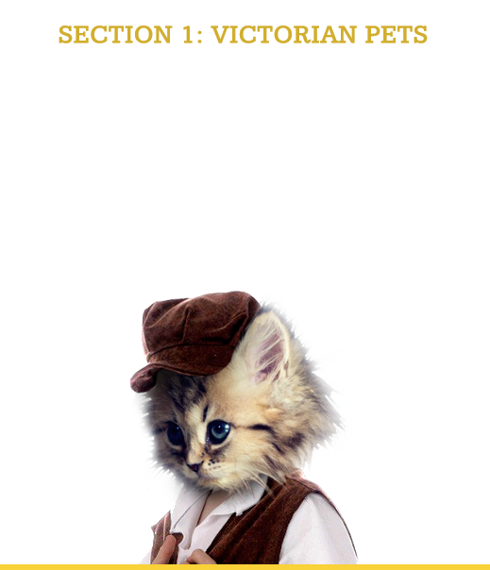
During the Victorian period domestic animals, such as cats and dogs, were typically treated as part of the family. However, just as in today’s society, attitudes to animals in the nineteenth and early twentieth centuries could be quite varied and often contradictory. Lots of people showed concern for domestic animals but working animals suffered greatly and exotic creatures had a hard time as well.

A Dog’s Life
Illustrated cartoon from the Graphic, 1891: Tale of a Dog – told by himself
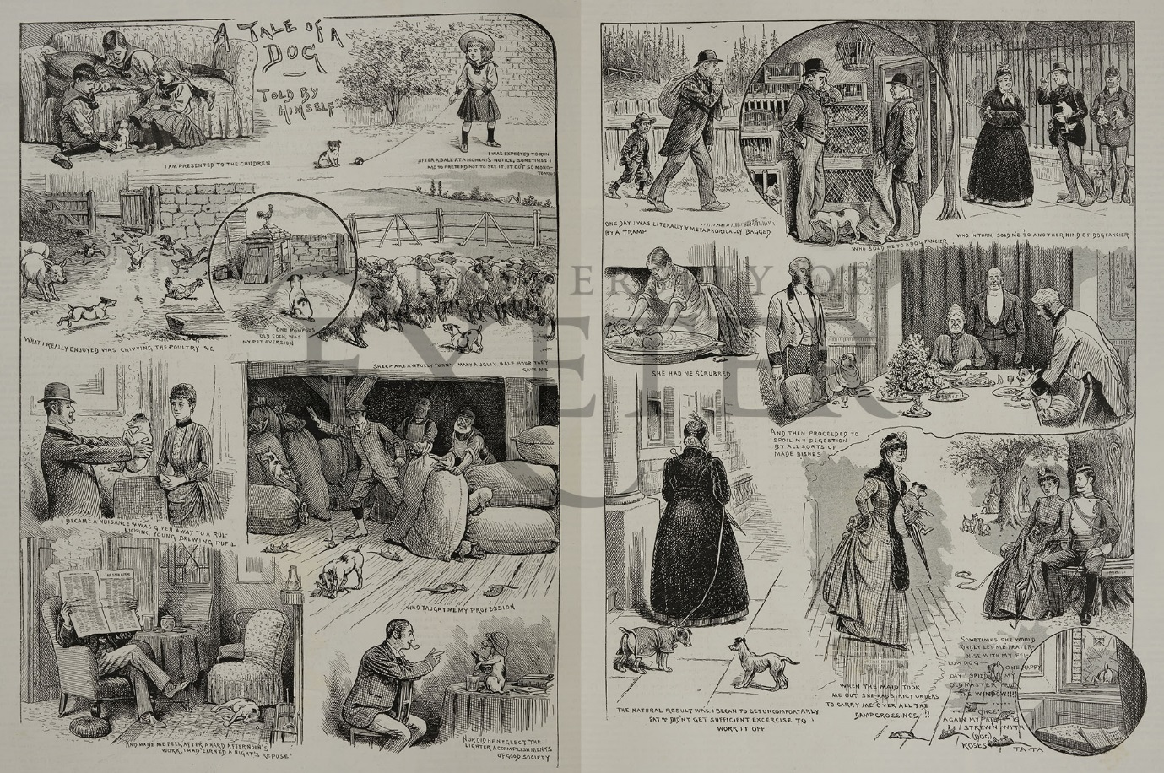

Pet Dog Clubs
Text: Feminine dog-lovers in New York, from the Graphic 1891
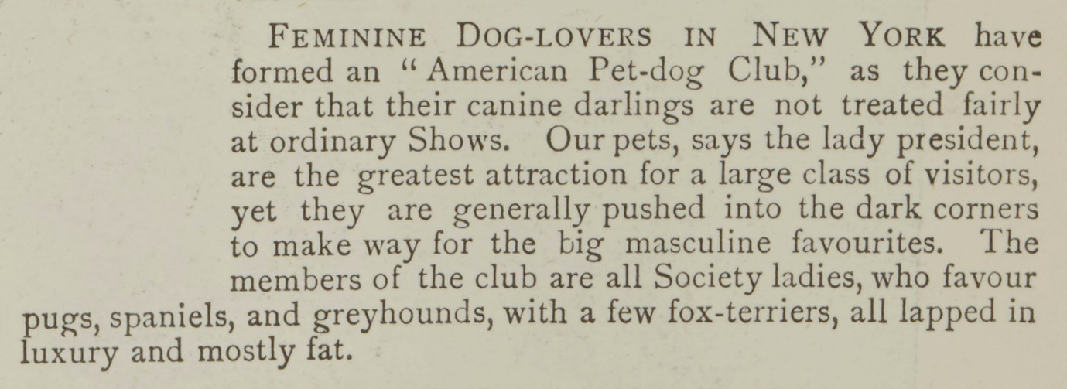
------------------------------------------------------------------------------------------------
Transcript:
FEMININE DOG-LOVERS IN NEW YORK have formed an “American Pet-dog Club”, as they consider that their canine darlings are not treated fairly at ordinary Shows. Our pets, says the lady president, are the greatest attraction for a large class of visitors, yet they are generally pushed into the dark corners to make way for the big masculine favourites. The members of the club are all Society ladies, who favour pugs, spaniels, and greyhounds, with a few fox-terriers, all lapped in luxury and mostly fat.
------------------------------------------------------------------------------------------------

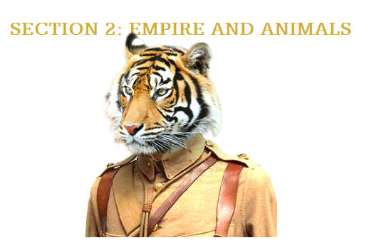

During the Victorian period Britain conquered and claimed the right to rule as an imperial power over large areas, including much of India and parts of Africa. This meant that British people encountered a lot of different animals that were shipped over from the colonies – both dead and alive. Elephants, tigers and zebras would emerge in crates at London Dock and be taken to zoos, menageries and circuses. If you had enough money you could even purchase exotic animals as pets. It sounds fun but in reality these wild animals suffered from not being in their natural habitats.

Hunting Exotic Animals
Text and illustration: Front cover of the Graphic, 24 Oct 1891
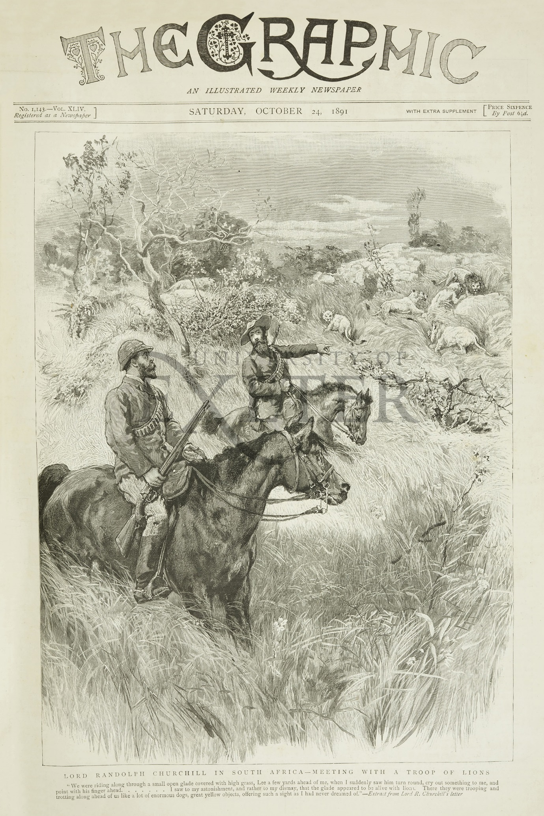
------------------------------------------------------------------------------------------------
Transcript:
Lord Randolph Churchill in South Africa – meeting with a troop of lions
“We were riding along through a small gate covered with high grass, Lee a few yards ahead of me, when I suddenly saw him turn around, cry out something to me, and point with his finger ahead ……. I saw to my astonishment, and rather to my dismay, that the glade appeared to be alive with lions. There they were trooping and trotting along ahead of us like a lot of enormous dogs, great yellow objects, offering such a sight as I had never dreamed of.” – Extract from Lord R. Churchill’s letter.

------------------------------------------------------------------------------------------------

Victorian Zoos
Illustration: ‘Sunday afternoon at the zoological gardens’, from the Graphic, 21 Nov 1891
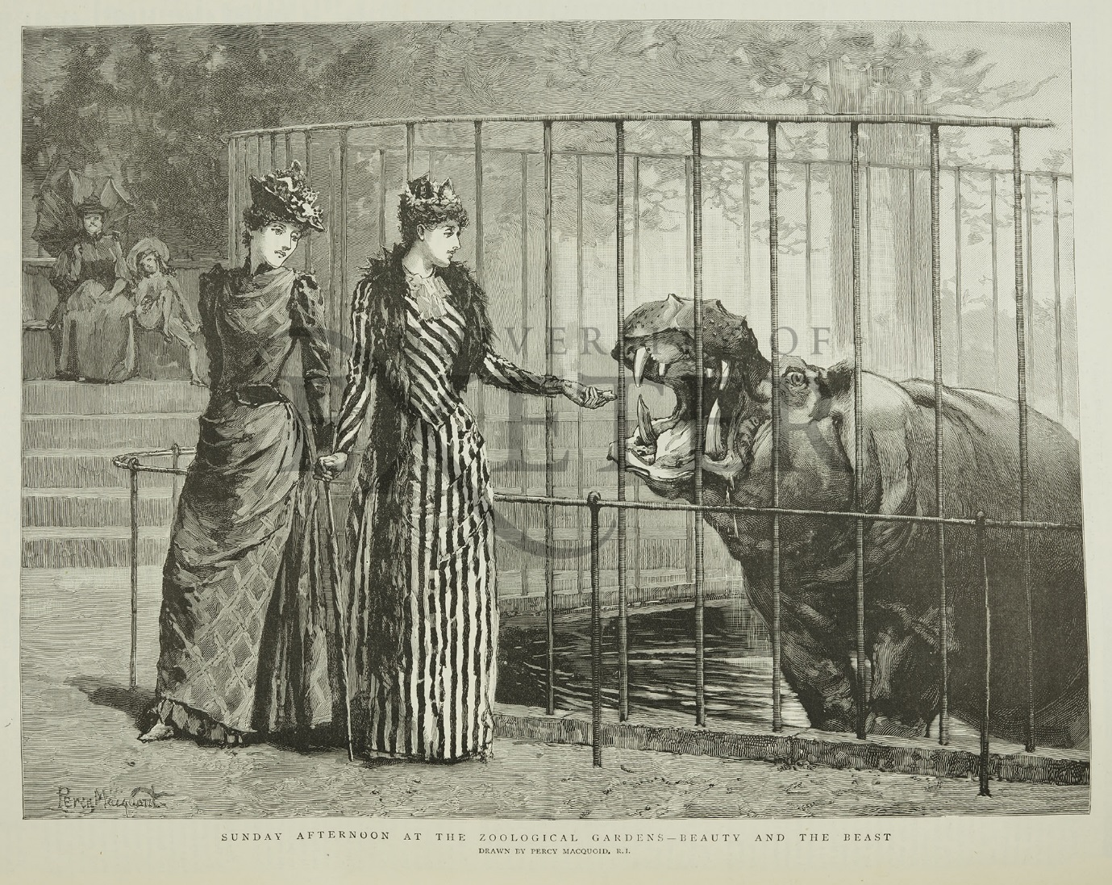

------------------------------------------------------------------------------------------------
Transcript:
SUNDAY AFTERNOON AT THE ZOOLOGICAL GARDENS – BEAUTY AND THE BEAST
------------------------------------------------------------------------------------------------

Victorian Naturalists
Text and illustration: ‘The Naturalist’ from the Graphic, 31 Oct 1891

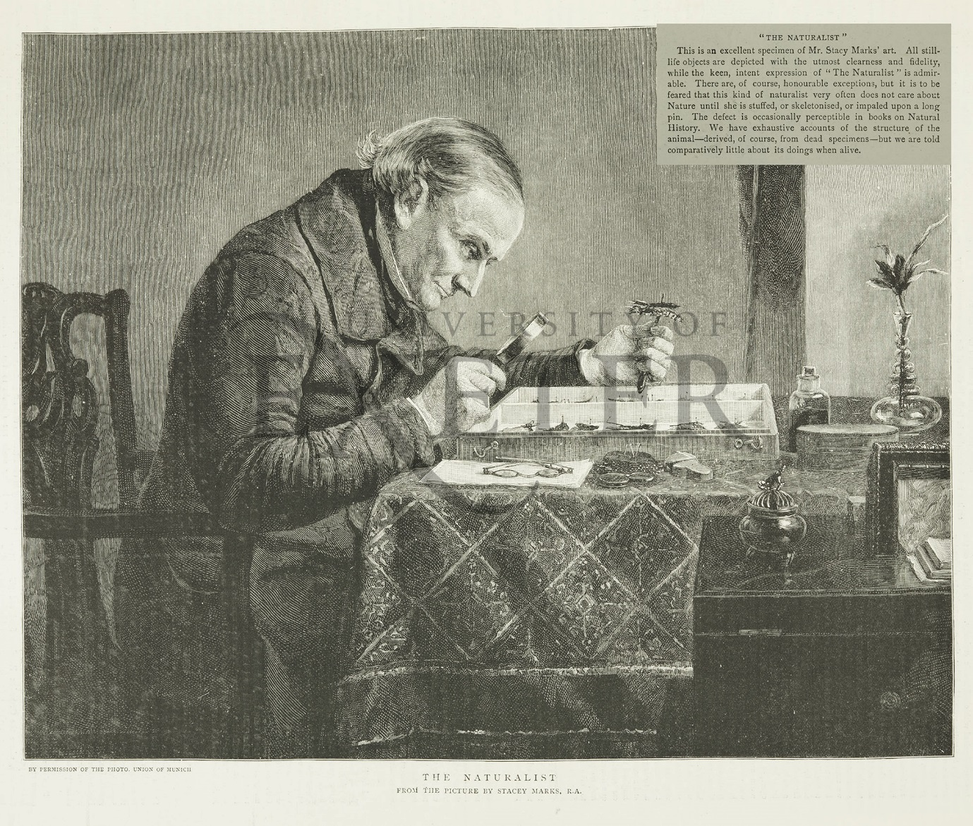
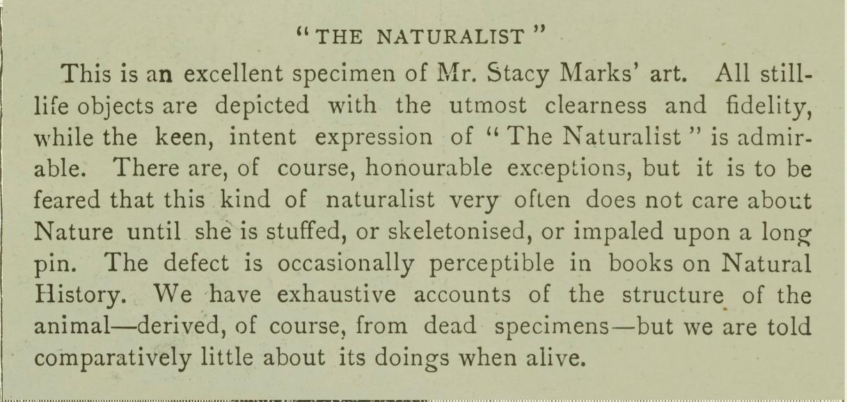
------------------------------------------------------------------------------------------------
Transcript:
“The Naturalist”
This is an excellent specimen of Mr. Stacy Marks’ art. All still-life objects are depicted with the utmost clearness and fidelity, while the keen, intent expression of “The Naturalist” is admirable. There are, of course, honourable exceptions, but it is to be feared that this kind of naturalist very often does not care about Nature until she is stuffed, or skeletonised, or impaled upon a long pin. The defect is occasionally perceptible in books on Natural History. We have exhaustive accounts of the structure of the animal – derived, of course, from dead specimens – but we are told comparatively little about its doings when alive.
------------------------------------------------------------------------------------------------

Wild Birds
Text: ‘Bird Freedom’, from the Graphic, 2 May 1891

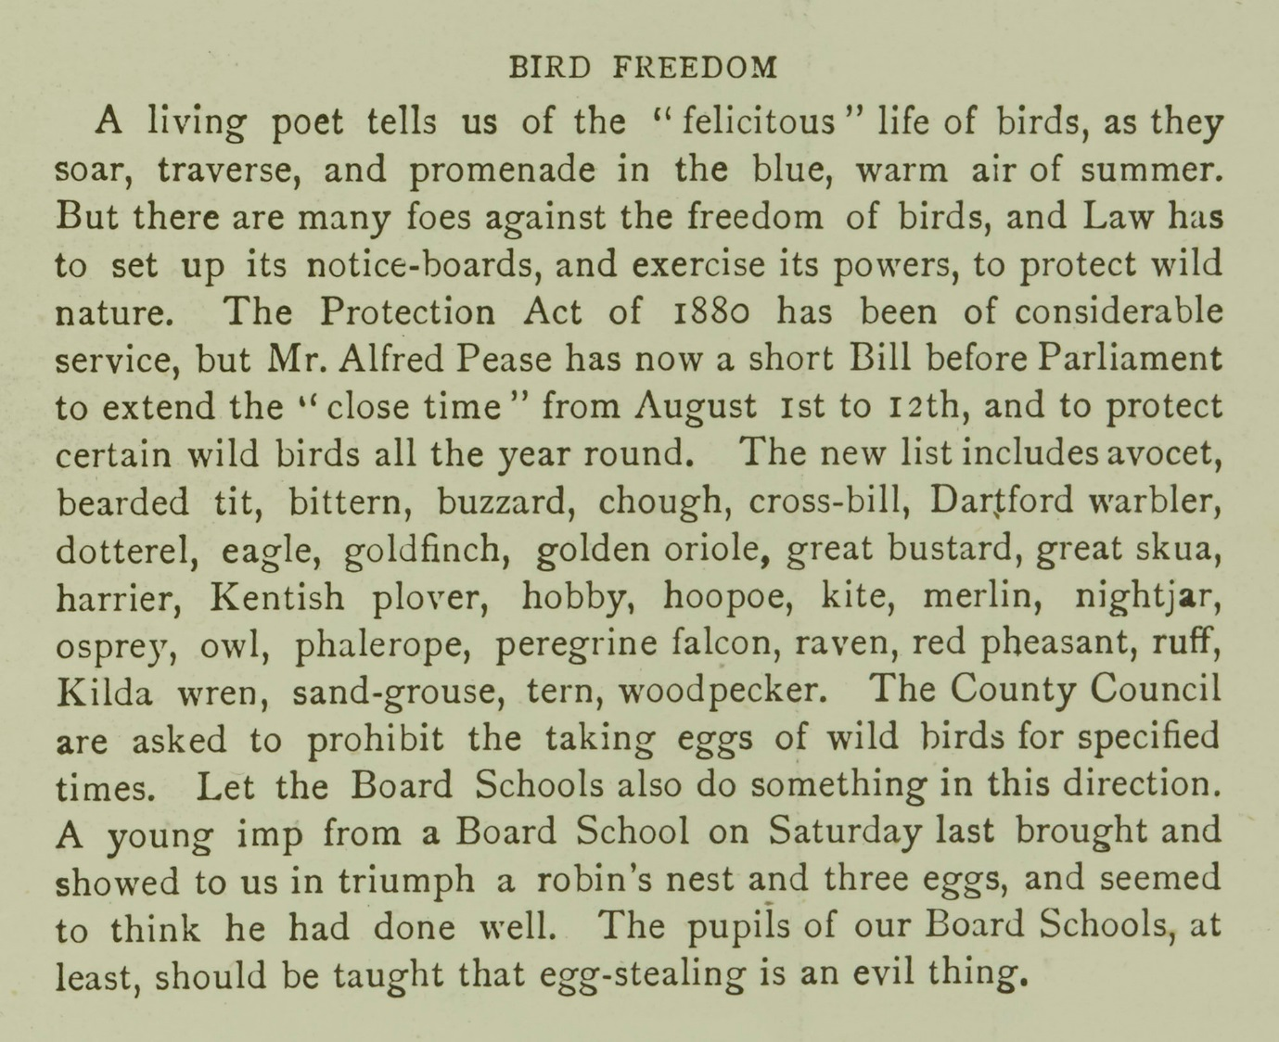

------------------------------------------------------------------------------------------------
Transcript:
Bird Freedom
A living poet tells us of the “felicitous” life of birds as they soar, traverse, and promenade in the blue, warm air of summer. But there are many foes against the freedom of birds, and Law has to set up its notice-boards, and exercise its powers, to protect wild nature. The Protection Act of 1880 has been of considerable service, but Mr Alfred Pease has now a short Bill before Parliament to extend the “close time” from August 1st to 12th, and to protect certain wild birds all the year round. The new list includes avocet, bearded tit, bittern, buzzard, chough, cross-bill, Dartford warbler, dotterel, eagle, goldfinch, golden oriole, great bustard, great skua, harrier, Kentish plover, hobby, hoopoe, kite, merlin, nightjar, osprey, owl, phalarope, peregrine falcon, raven, red pheasant, ruff, Kilda, wren, sand-grouse, tern, woodpecker. The County Council are asked to prohibit the taking eggs of wild birds for specified times. Let the Board Schools do something in this direction. A young imp from a Board School on Saturday last brought and showed to us in triumph a robin’s nest and three eggs, and seemed to think he had done well. The pupils of our Board Schools, at least, should be taught that egg-stealing is an evil thing.
------------------------------------------------------------------------------------------------

Performing Animals
Text and illustration: ‘Trained wild beasts at the Crystal Palace’, from the Graphic, 23 May 1891

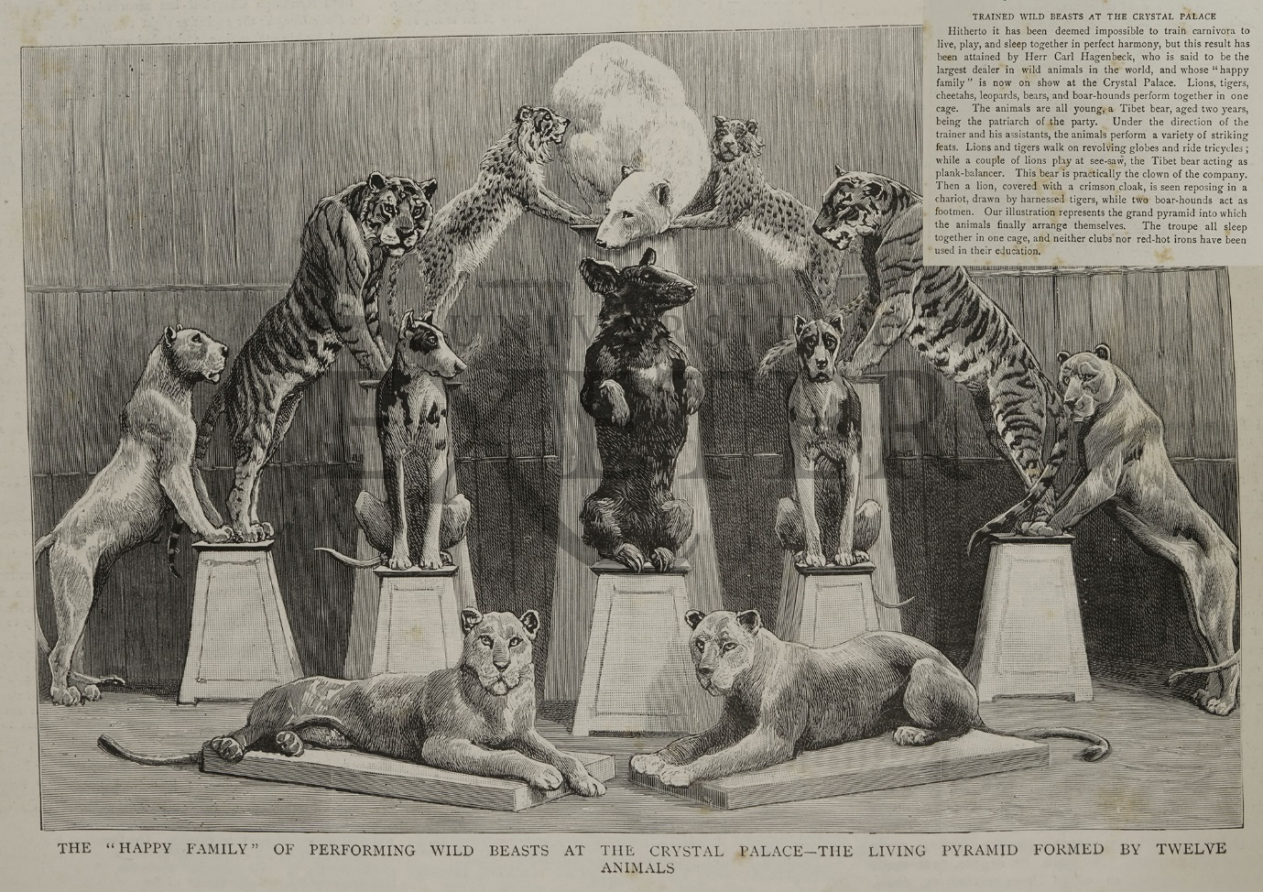

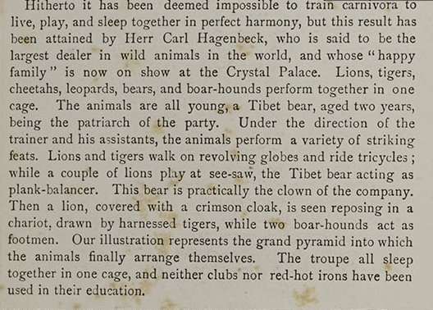
------------------------------------------------------------------------------------------------
Transcript:
Hitherto it has been deemed impossible to train carnivora to live, play, and sleep together in perfect harmony, but this result has been attained by Herr Carl Hagenbeck, who is said to be the largest dealer in wild animals in the world. And whose “happy family” is now on show at the Crystal Palace. Lions, tigers, cheetahs, leopards, bears, and boar-hounds perform together in one cage. The animals are all young, a Tibet bear, aged two years, being the patriarch of the party. Under the direction of the trainer and his assistants, the animals perform a variety of striking feats. Lions and tigers walk on revolving globes and ride tricycles; while a couple of lions play at see-saw, the Tibet bear acting as plank-balancer. This bear is practically the clown of the company. Then a lion, covered with a crimson cloak, is seen reposing in a chariot, drawn by harnessed tigers, while two boar-hounds act as footmen. Our illustration represents the grand pyramid into which the animals finally arrange themselves. The troupe all sleep together in one cage, and neither clubs nor red-hot irons have been used in their education.

Illustration caption: THE “HAPPY FAMILY” OF PERFOMRING WILD BEASTS AT THE CRYSTAL PALACE – THE LIVING PYRAMID FORMED BY TWELVE ANIMALS
------------------------------------------------------------------------------------------------

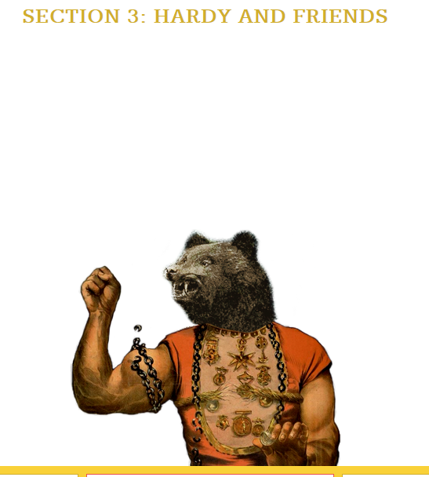

The writer and poet Thomas Hardy was born in 1840 and lived three decades into the twentieth century. This last section features some letters from his later life. Hardy was very concerned about questions of animal welfare. He and his first wife, Emma Hardy, his second wife, Florence Hardy, and his good friend Florence Henniker, were united in their wish to bring about changes in attitudes to animal welfare, including the treatment of horses in war.
Thomas Hardy and his pets
Text: Letter from Hardy’s friend, Berkeley C. Williams, written just after the death of Hardy’s dog Wessex in 1927.

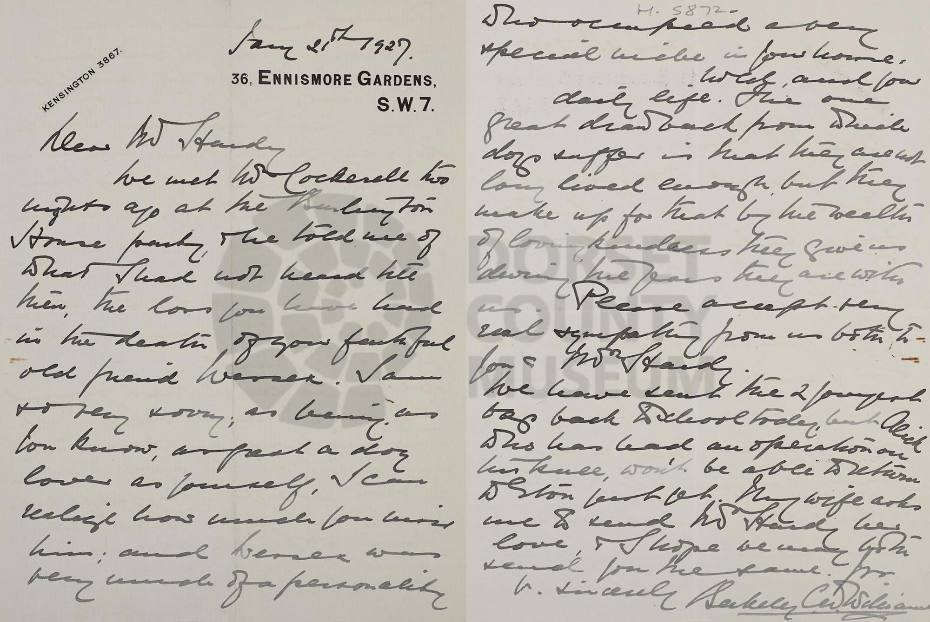
------------------------------------------------------------------------------------------------
Transcript:
Dear Mr. Hardy
We met Mr Cockerell two nights ago at the Burlington House party & he told me of what I had not heard till then, the loss you have had in the death of your faithful old friend Wessex. I am so very sorry; as being as you know, as great a dog-lover as yourself, I can realise how much you miss him; and Wessex was very much of a personality who occupied a very special niche in your home, world and your daily life. The one great drawback from which dogs suffer is that they are not long lived enough but they make up for that by the wealth of loving kindness they give us during the years they are with us. Please accept my very real sympathy from us both to you & Mrs Hardy.

We have sent the 2 youngest boys back to school today but Alick who has had an operation on his knee, won't be able to return to Eton just yet. My wife asks me to send Mrs Hardy her love, & I hope we may both send you the same.
Yrs v. sincerely
Berkeley C W Williams
------------------------------------------------------------------------------------------------

Hardy’s Protest
Text: Extract from a letter written by Hardy to his friend Florence Henniker, 21 Dec 1913

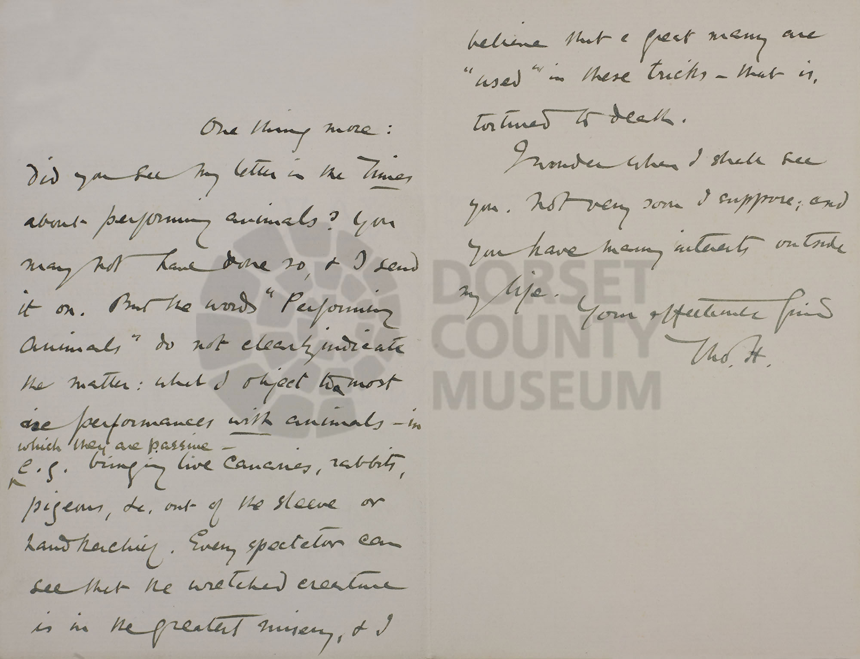

------------------------------------------------------------------------------------------------
Transcript:
One thing more: did you see in The Times about performing animals? You may not have done so, & I send it on. But the words "Performing Animals" do not clearly indicate the matter: what I object to in most performances with animals – in which they are passive - e.g. bringing live canaries, rabbits, pigeons, etc. out of the sleeve or handkerchief. Every spectator can see that the wretched creature is in the greatest misery, & I believe that a great many are "used" in these tricks - that is, tortured to death.
I wonder when I shall see you. Not very soon I suppose: and you have many interests outside my life.
Your affectionate friend
Tho. H.
------------------------------------------------------------------------------------------------

Murderous Millinery
Text: Extract from a letter written by Florence Henniker to Hardy, 17 Jan 1914
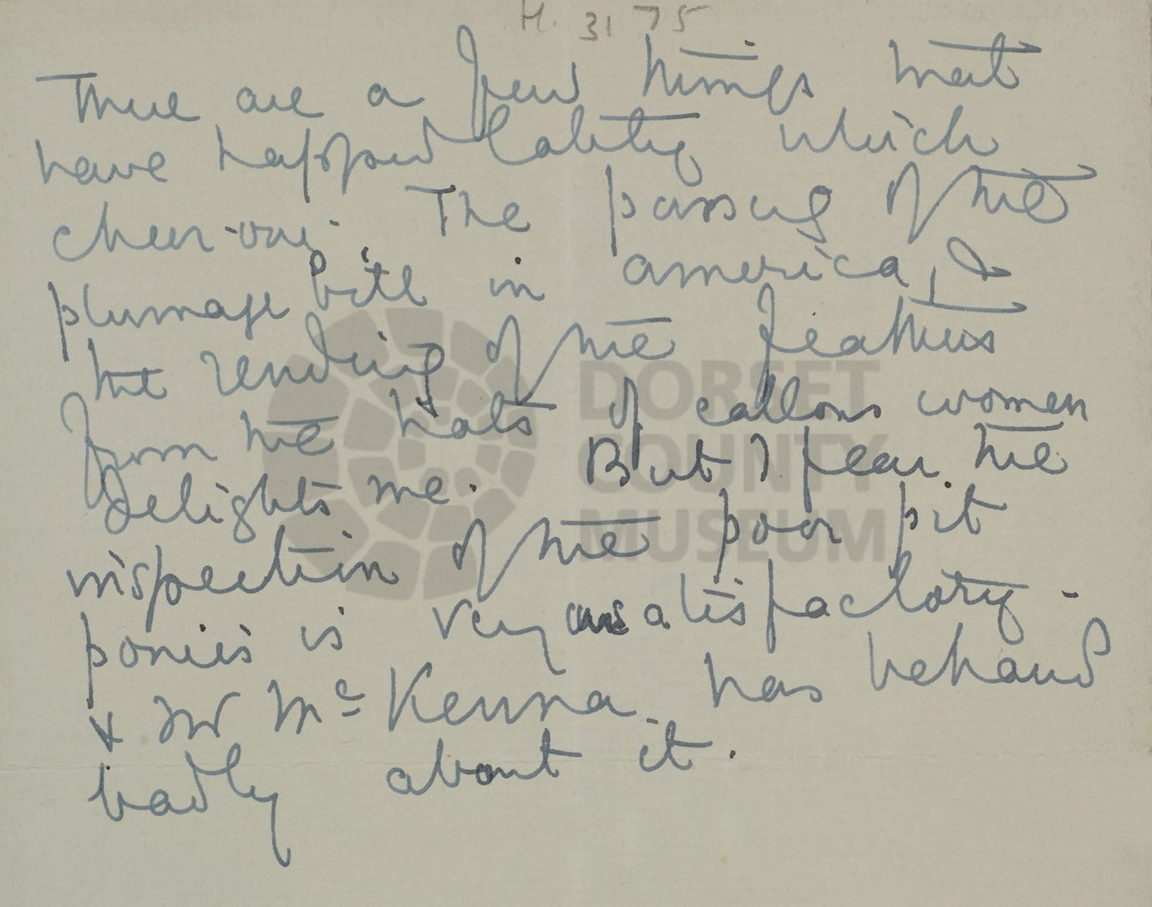
------------------------------------------------------------------------------------------------
Transcript:
There are a few things that have happened lately which cheer one. The passing of the Plumage Bill, & the rending of the feathers from the hats of callous women delights me. But I fear the inspection of the poor pit ponies is very unsatisfactory – & our M^{r} McKenna has behaved badly about it.

------------------------------------------------------------------------------------------------

