Animalistic references in Jekyll & Hyde: Session Plan

Topic | Context lesson to support the study of Strange Case Dr Jekyll and Mr Hyde  This session can be used to support crossover between GCSE English Language and GCSE English Literature.
Session Aims:
- To examine 19th-century non-fiction texts that enhance contextual understanding about attitudes to animals. This can be used to support analysis of animal references in Jekyll and Hyde.

Learning Outcomes:
By the end of the session learners will be able to. . .
- Discuss ideas about how animals were perceived during the Victorian period.
- Analyse the languge of non-fiction texts to identify underlying attitudes and viewpoints.
- Make links between the ideas explored in Jekyll and Hyde and the wider context of the Victorian period i.e. in relation to the publication of Darwin’s works.
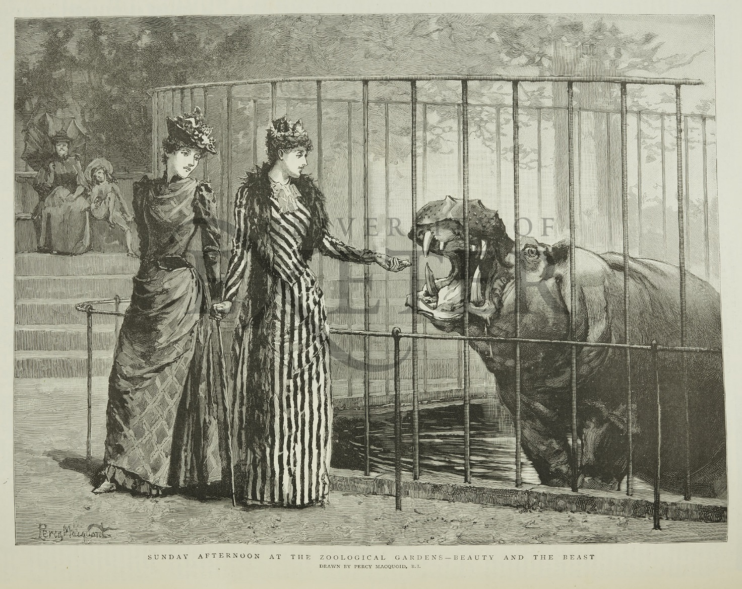

Timing | Activity | Resources
10-15 mins | Context: During the Victorian period, lots of zoos started to spring up across Europe as a way of displaying exotic animals captured from various parts of the Empire.  Starter – The illustration of two Victorian women looking at a hippo (from the Graphic, 1891) shows how a trip to the zoo became a normal part of Victorian life.  The image can be used as a starter resource to open up topic discussion. For example:  - What does this suggest about human and animal interaction in the Victorian period?  - How is the hippo portrayed?  - How is a contrast between the women and the animal established?  Looking at the caption, ‘Sunday afternoon at the zoological gardens – Beauty and the Beast’…  Q. How does the language used convey the relationship between the animals in the zoo and the people looking at them?  Students might want to research the fairy tale La Belle et la Bête (1740) and Andrew Lang’s version of the tale published in the Blue Fairy Book of his Fairy Book series in 1889. | Illustration from the Graphic (above)
Part 2
Context: Victorian Naturalists
During the Victorian period, collecting and studying animals, birds and insects was a pretty normal hobby – at least for those with enough money to fund their interests. It was seen as educational and became a way of advancing scientific knowledge; Darwin’s evolutionary theories came from just this kinds of study.

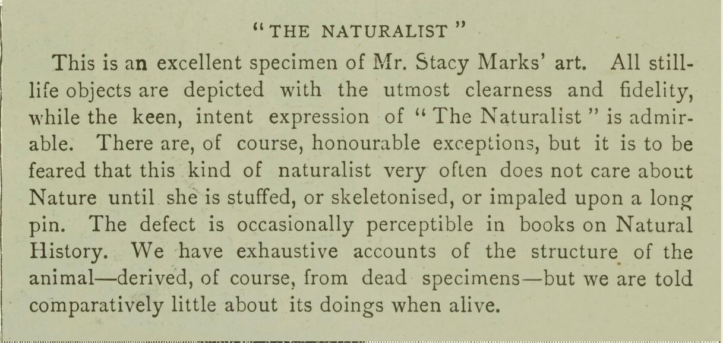

Transcript:

“The Naturalist”

This is an excellent specimen of Mr. Stacy Marks’ art. All still-life objects are depicted with the utmost clearness and fidelity, while the keen, intent expression of “The Naturalist” is admirable. There are, of course, honourable exceptions, but it is to be feared that this kind of naturalist very often does not care about Nature until she is stuffed, or skeletonised, or impaled upon a long pin. The defect is occasionally perceptible in books on Natural History. We have exhaustive accounts of the structure of the animal – derived, of course, from dead specimens – but we are told comparatively little about its doings when alive.
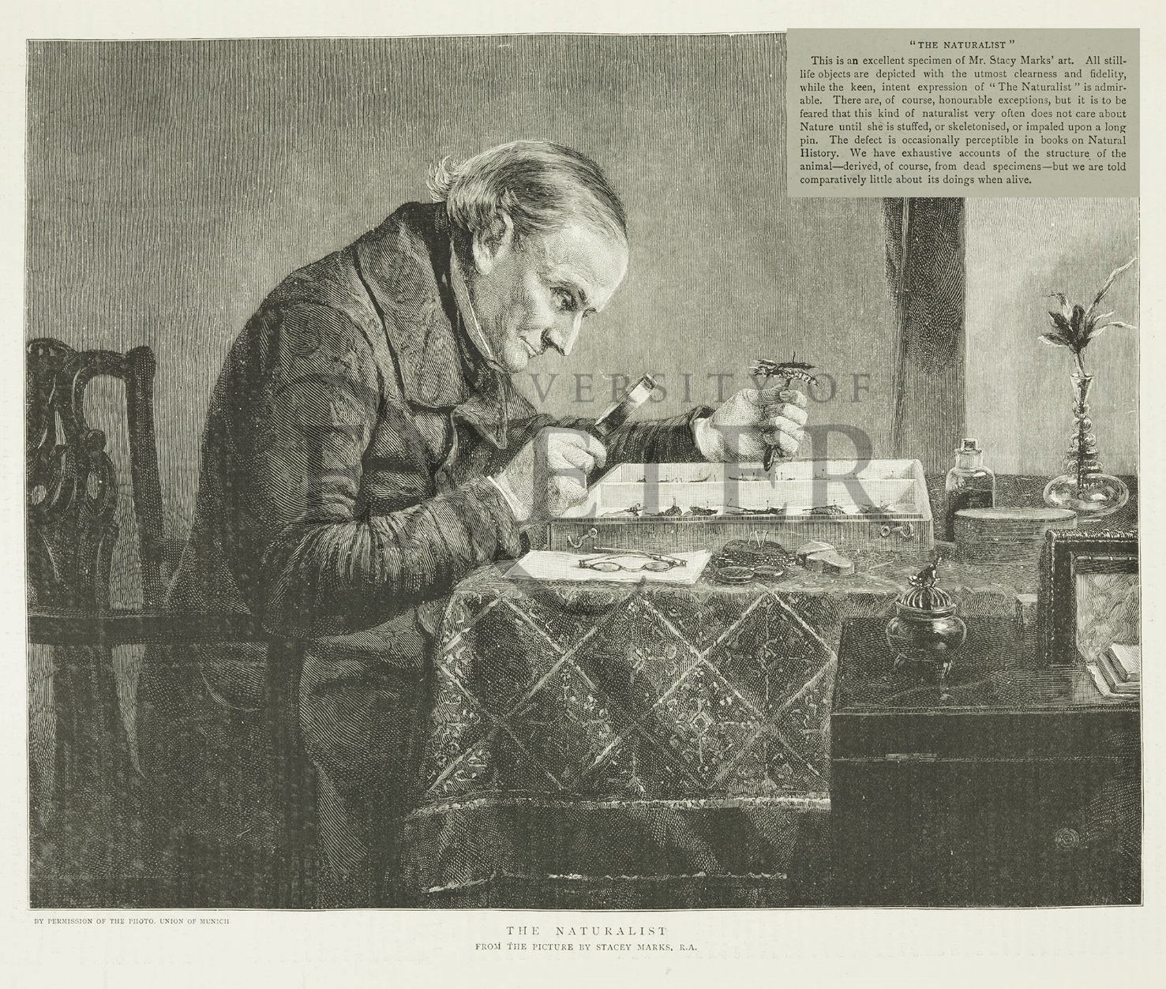

15 – 20 mins | Read the article about naturalists from the Graphic, 31 October 1891.  Q) How does the writer use the rule of three in ‘stuffed, or skeletonised, or impaled upon a pin’ – to convey a negative attitude about this activity?  What do you think about the work of naturalists? What are the positive and negatives of their work?  [This could then be compared to the work of David Attenborough on the BBC and new documentaries, such as, The Secret Life of the Zoo, that aim to educate and explain animal behaviours by studying them in the wild or in captivity.  (Clips from these programmes could be included in the lesson.) | Article ‘The Naturalist’ and accompanying illustration (above)
Part 3
5 mins  15 mins | Making links with Jekyll and Hyde:  Context: Charles Darwin’s On the Origin of Species (1859) was one of the most influential texts of the nineteenth century, introducing new possibilities of change and transformation. Darwin’s theory of evolution encouraged some Victorians to think about ideas of progress and to compare Victorian society with other societies and civilizations both past and present. But a theory of evolution that held that development was from the rudimentary to the complex also invited the possibility of the process going into reverse.  One of Darwin's other publications was The Descent of Man (1871) which explored the relation of humans and animals. Some Victorians were shocked by the link suggested between humans and primates and others explored the notion that humans could degenerate into animals. Degeneration was constructed by some Victorians as a moral threat, the cause of crime etc., and even poverty, with some writers choosing to portray criminals and prostitutes as examples of how the species might be degenerating. These sorts of reactions are explored in Jekyll and Hyde as Mr Hyde is often described in animalistic ways.  A number of writers, including Hardy, used their works to advocate for animals and develop fellow-feeling with them, exploring human animal connections in positive ways. | Extract from Jekyll and Hyde (see page 6 of this session plan).
Written task: Write an analytical paragraph using quotations from the extract to explore how and why Stevenson includes animalistic references in his text.
Aim to include a contextual point based on what you have learnt in the first two parts of this lesson.
(As a way into this activity, students could draw their version of Hyde using the animalistic references they have picked up on earlier in the narrative.)

Consolidation activity
Students can find out more about attitudes to animals in the 19th- and early 20th- centuries by exploring other non-fiction texts in our online resourse: http://hardyandheritage.exeter.ac.uk/gcse-english-language-revision/

Extract from Jekyll’s confession towards the end of Chapter 10:

[B]ut I was still cursed with my duality of purpose; and as the first edge of my penitence wore off, the lower side of me, so long indulged, so recently chained down, began to growl for licence. Not that I dreamed of resuscitating Hyde; . . . no, it was in my own person that I was once more tempted to trifle with my conscience. . . .
[However,] this brief condescension to my evil finally destroyed the balance of my soul. And yet I was not alarmed; the fall seemed natural, like a return to the old days before I had made discovery. It was a fine . . . day. . . . I sat in the sun on a bench; the animal within me licking the chops of memory; the spiritual side a little drowsed, promising subsequent penitence, but not yet moved to begin. After all, I reflected, I was like my neighbours; and then I smiled, comparing myself with other men, comparing my active goodwill with the lazy cruelty of their neglect. And at the very moment of that vainglorious thought, a qualm came over me, a horrid nausea and the most deadly shuddering. . . . I began to be aware of a change in the temper of my thoughts, a greater boldness, a contempt of danger, a solution of the bonds of obligation. I looked down; my clothes hung formlessly on my shrunken limbs; the hand that lay on my knee was corded and hairy. I was once more Edward Hyde.

